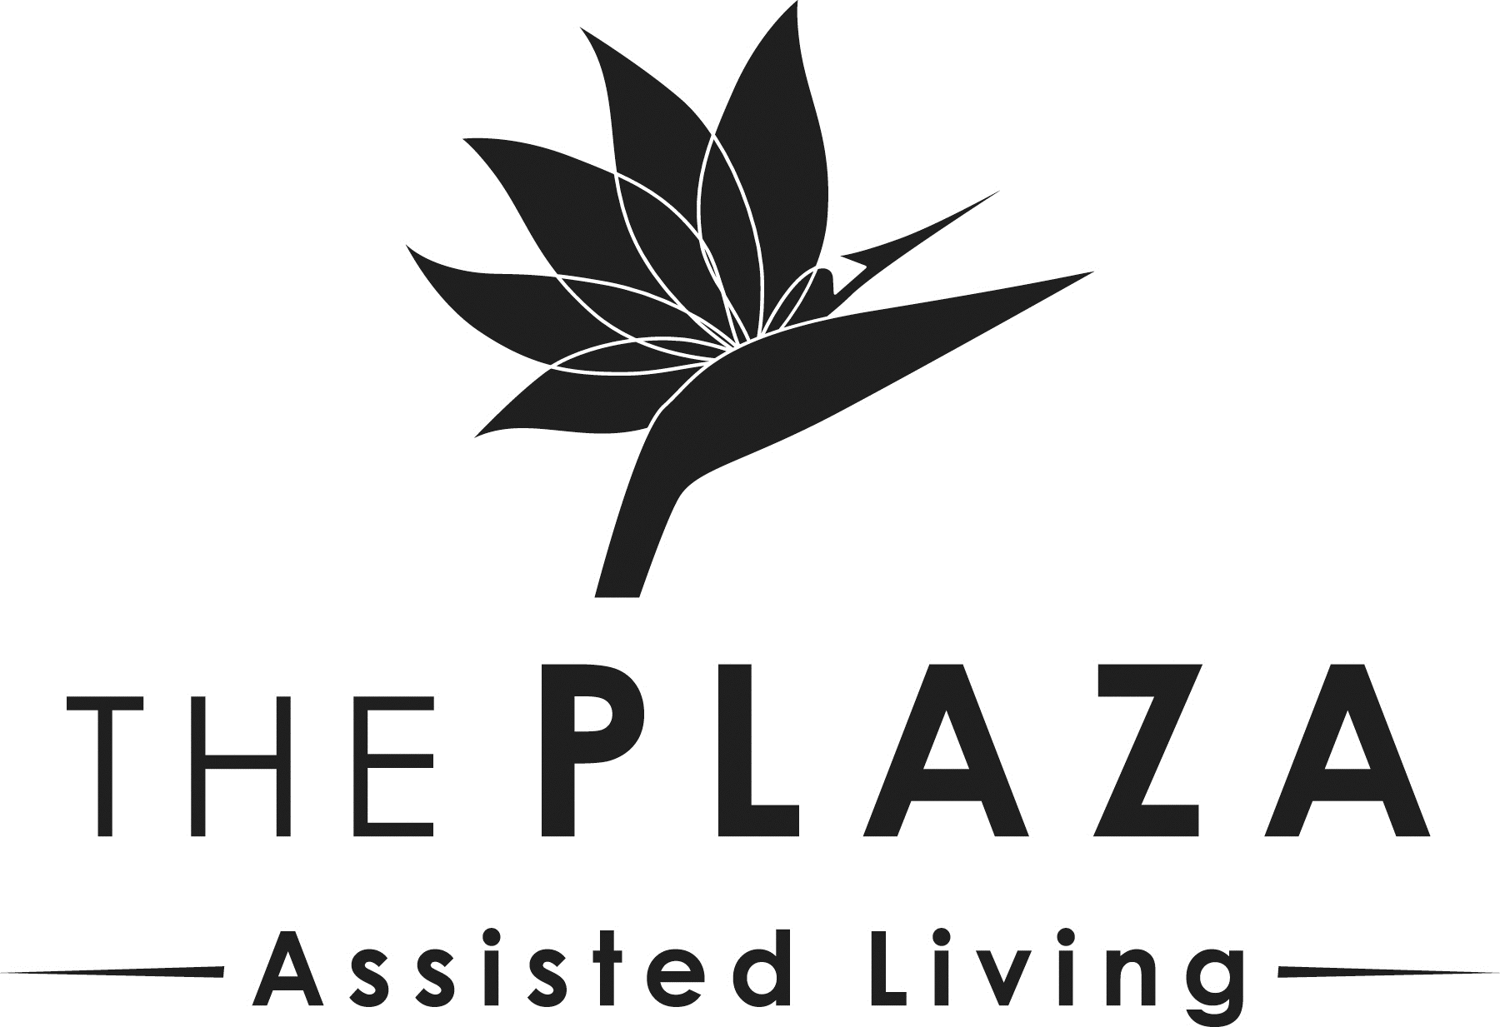

MY NEW APARTMENT

Furniture: A microwave, refrigerator, and air conditioner are provided with each apartment. Residents should provide any additional furniture to meet their needs. Furniture items are also available for purchase.

Blinds/Curtains: White blinds are provided with your apartment. Residents are permitted to hang their own curtains, but we ask that the blinds remain on the windows.

Linens: The Plaza will provide you with towels, which will be laundered once per week on your assigned housekeeping day. Residents may also provide their own decorative towels that The Plaza can launder upon request. The Plaza can also provide white twin-sized sheets, a twin-sized blanket, and pillowcases, or residents may bring their own. If you choose to use a bed size other than twin, please bring two sets of sheets and properly label them.

Rugs: The Plaza will provide a bathmat, which will be laundered once per week. Residents may bring their own bathmats, but they must have a non-slip material underneath. Rugs in the apartment are not recommended, as they can be a trip hazard.

Shower: The shower curtain in your apartment is a standard white curtain. Residents may change or add another curtain if they wish. If you choose to place permanent non-slip pads on the floor of the shower, you may incur removal charges upon moving out of the apartment.

Pictures: Residents are encouraged to hang their own pictures or seek assistance from our maintenance staff. Maintenance requests can be made through the concierge desk.

Storage: There is no additional on-site storage for residents, but there are many public storage facilities in the nearby area.

Safety: Due to fire code, residents are not permitted to use extension cords. However, surge protectors are permitted, but may not piggyback another surge protector. Having an appliance, other than the microwave and refrigerator that come with the apartment, must first be approved by the Administrator and the Director of Maintenance and Housekeeping. Additional locks are not permissible.

Trash: We will provide small trash liners for trash cans, and will empty them weekly.

Recommended Supplies:
- Shampoo, conditioner, soap, toothbrush, toothpaste, floss, razor, shaving cream, deodorant, brush/comb, moisturizer
- Toilet paper, Kleenex, paper towel
- Comforter, pillow, hangers, alarm clock
- Snacks
- Trash can (The Plaza provides small liners only).
- Lamps (light bulbs are only provided for lighting fixtures provided by The Plaza)
- Incontinence products (depends, pads, disposable wipes, etc.)
- Personal clothing (Please label with your name and bring enough clothing for at least 10 days).

